My Mom Carrie Bolin
By: Dylan Page

Birthplace and Date
My mom was born on October 3rd, in Stephen’s County, Georgia.
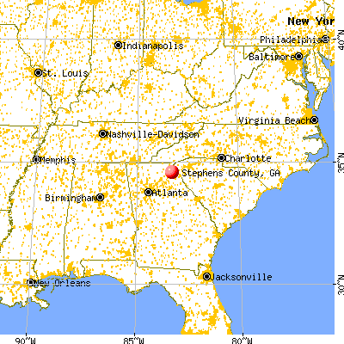

Family
My mom has 2 half brothers. They are Eric and Matthew. They live in Georgia.

Places Lived
My mom lived in Georgia when she was born, and she moved to South Carolina later in her life.

Hobbies
My mom’s hobbies are studying, reading, listening to music, and doing yard work.

Occupations
Her occupations are CNC Machinist, and future nurse. She used to work at Hoke but she quit because they treated her like dogs, and she is going to college to become a nurse.

Significant Events
My mom’s significant events in her life are having kids, losing her mom, going back to college, and getting remarried.

All About the Author
My name is Dylan Page. Born on February 1st, 2000 while I grew up I mostly played video games, and watched TV. I am in fourth grade and I am 10.

